**CSE 423 Final Suggestion**

1. Determine the coordinate of a 3D point P(100, -60, 80) after rotating 600 across Y-axis, given that the center of rotation is (50, 20, 45).
2. Determine the coordinate of a 3D point P(100, -60, 80) after rotating 600 across X-axis, given that the center of rotation is (50, 20, 45).
3. Determine the coordinate of a 3D point P(100, -60, 80) after rotating 600 across Z-axis, given that the center of rotation is (50, 20, 45).
4. Find the following composite transformation matrices as instructed:
   1. A 3D rotation of 90 degree clockwise about y-axis with respect to the point (a, b, c) followed by a translation of (a, b, c).
   2. A reflection about the line ax - by + c = 0 followed by a scaling “e” times with respect to the point (a, b).
   3. A 3D rotation of 45 degree counterclockwise about z-axis with respect to point (d, e, f) followed by a uniform scaling of factor 3 with respect to point (d, e, f) and lastly followed by a translation of (a, b, c).

[Here a,b,c,d,e,f are arbitrary values]

1. Let a 3D point (423, -423, 423) be projected on a projection plane. Given that the center of the projection plane is (0.0, 0.0, -423.0) and the coordinate of the COP is (4, 2, 3). Determine the coordinate of that 3D point on the projection plane using a general purpose perspective projection matrix.
2. A 3D vertex P(40.0, 30.0, 20.0) is projected on the projection plane. Determine the projected coordinate P’ on the projection plane using the following projection matrix:

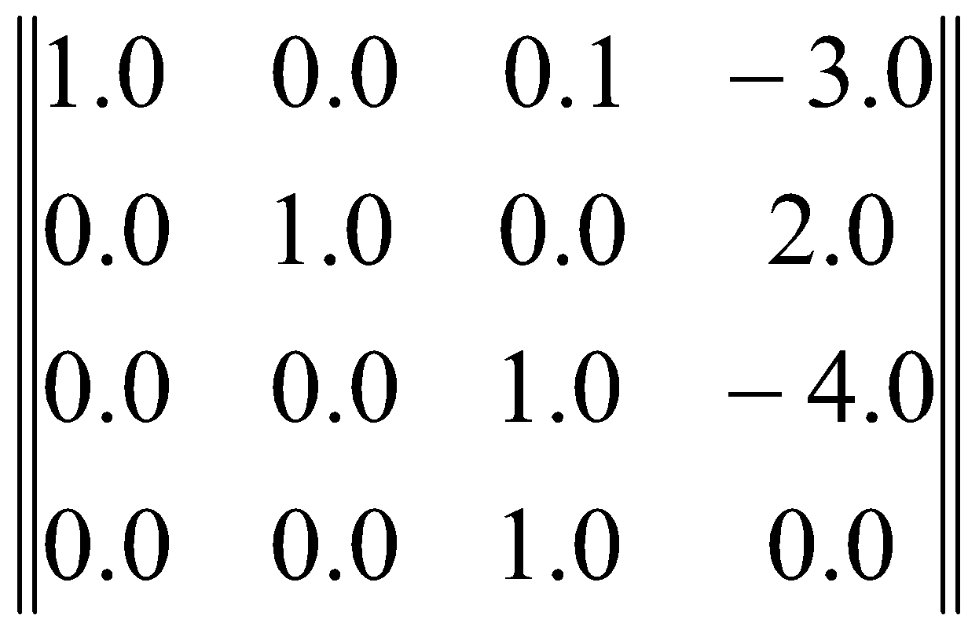

.

1. Let (50, 70, 1500) be the coordinate of a light source of intensity 0.95 units. The light is illuminating a sphere whose center is at C(10, -15, 6). Determine the intensity of the reflected light from a point P(20, 10, 120) on the sphere using a diffuse reflection model. Given that the diffuse absorption coefficient of the quad surface is 0.8 unit.
2. Convert the RGB colors into HLS/HSL color values.

(i) (0.25, 0.3, 1.0) (ii) (0.01, 1.0, 0.09) (iii) (0.8, 0.8, 0.35) (iv) (0,0, 0,4, 0.4)

(v) (1.0, 1.0, 0.5) (vi) (0.7, 0.71, 0.7) (vii) (0.5, 0.5 , 0.5) (viii) (1,0, 1,0, 1.0)

1. To answer some of the following questions, you will need four variables A, B, C and D which are sequentially the first, second, third and fourth pair of digits from the left in your student ID.

For example, if your ID is 15101208, then A= 15, B= 10, C= 12 and D= 8.

1. A color is given in CMY form with the values (0.A, 0.C, 0.D). Convert the color into an equivalent HSV model. Show the calculation in detail.
2. The color at vertex A is value B of your student ID and at vertex C is D of your student ID. Now calculate the color at point X using Gouraud shading. Can a specular light on point X be captured using the above model? Why or why not?

**

*—----------------------------------------------------------*

1. Define a homogeneous coordinate system. Why does computer-graphics prefer a homogeneous coordinate system?
2. Make a simple classification tree of transformations/motions.
3. Derive |4x4| rotation matrix for a 3D point rotation across Y-axis and the center of rotation is (a, b, c).
4. Derive |4x4| rotation matrix for a 3D point rotation across X-axis and the center of rotation is (a, b, c).
5. Derive |4x4| rotation matrix for a 3D point rotation across Z-axis and the center of rotation is (a, b, c).
6. Derive |3x3| transformation matrix for reflection about any line L.
7. Explain diffuse reflection model and give a real-life example of only diffuse reflection.
8. Explain specular reflection model and give a real-life example of only specular reflection.
9. Explain Light Source attenuation.
10. Make a comparison between additive and subtractive color models.
11. Draw RGB and CMY color cube.
12. Draw RGB and CMY color cube. Also, make a distinction between CMY and CMYK
13. Explain HLS/HSL Color Model using proper figures.
14. Write an algorithm for converting the RGB color values into HLS/HSL color values.
15. Write an algorithm for converting the RGB color values into HSV/HSB color values.